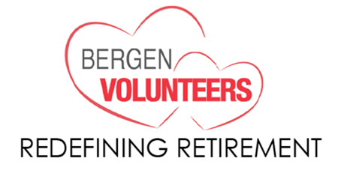
Let’s Create Meaningful Action, together!
We believe that retirees have much to offer their communities and are excited that you are interested in becoming a Redefining Retirement Volunteer. This is an opportunity to turn your caring into meaningful action!

By providing your contact information below, someone from the program will be in touch with you, or you can drop in to any of our information sessions to find out how your life experience, skills and interests will help a non-profit agency serving our Bergen County communities –and together, create a successful volunteer experience.

We’re looking forward to speaking with you soon!
______________________________________________________________________________
☐ Yes, I am interested in learning more about becoming a Redefining Retirement Volunteer
to work with a Bergen County nonprofit organization or social service agency.
Name: Click here to enter text.
Home address Click here to enter text.
Preferred phone number Click here to enter text. ☐ home ☐ mobile
Email address: Click here to enter text.
Emergency Contact Name and Phone number: Click here to enter text.

If you have a specific area of interest, or type of volunteer experience in mind, please let us know:
Click here to enter text.

Please describe any work or life experiences you would like to use in a volunteer role, or let us know if you want to try something new: Click here to enter text.

Thank You for your interest in improving lives and strengthening your community!
Please return form to retirement@bergenvolunteers.org or mail to Bergen Volunteers Attn: Redefining Retirement at 64 Passaic Street, Hackensack, NJ 07601

